Section One (calculator-free) 40 marks

This section has eight (8) questions. Attempt all questions.

Suggested working time: 50 minutes

The following exact value table may be useful to answer questions in this examination.

 | 0⁰ | 30⁰ | 45⁰ | 60⁰ | 90⁰
Sin | 0 |  | 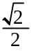 | 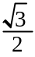 | 1
Cos | 1 |  |  |  | 0
Tan | 0 | 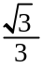 | 1 | 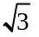 | undefined

Question 1: [7 marks – 1, 2, 1, 1, 1, 1]
Differentiate each of the following, simplifying fully:

a) 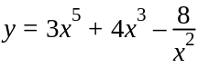 b) 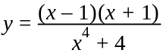 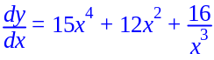

✓ 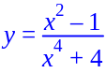
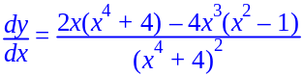 ✓
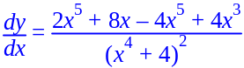
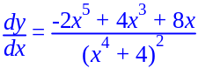 ✓

c) 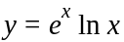 d) 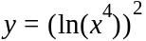

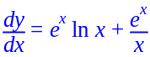 ✓ 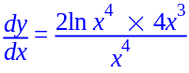
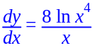 ✓

Question 1 cont…
e) 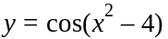 f) 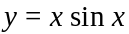

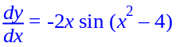 ✓ 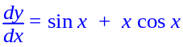 ✓

Question 2: [3 marks]
Determine 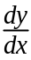 in terms of t for: 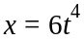, 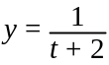.

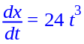 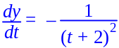 ✓ Differentiation

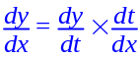

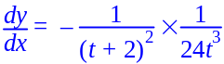 ✓

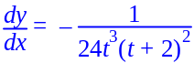 ✓

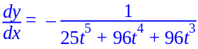

[3]

Question 3: [7 marks – 1, 1, 1, 1, 1, 2]

Integrate the following:

a) 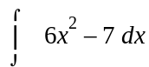 b) 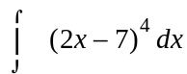

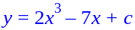 ✓ 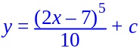 ✓

c) 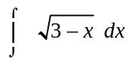 d) 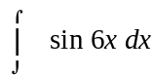

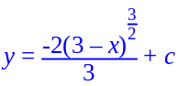 ✓ 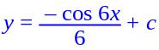 ✓

e) 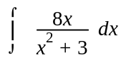 f) 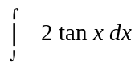

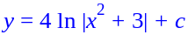 ✓ 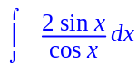 ✓

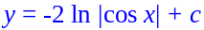 ✓

Question 4: [2 marks]
Determine a general solution to the differential equation: 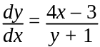. Simplify your solution fully.

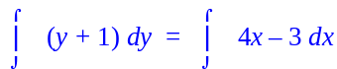 ✓

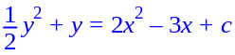 ✓

[2]

Question 5: [7 marks]
Determine if: 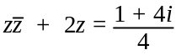.

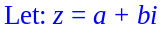
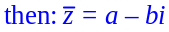

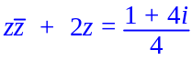
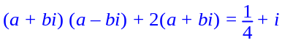 ✓
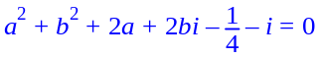 ✓

Im: 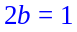
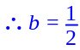 ✓

Real: 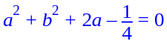 ✓
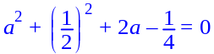
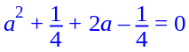
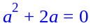
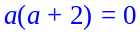

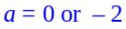
✓ ✓

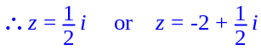 ✓ (- each mistake)

[7]

Question 6: [3 marks]
If 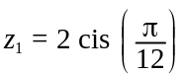 and 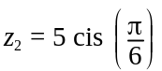, prove that: 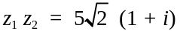

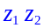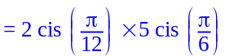

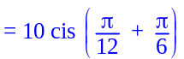

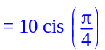 ✓

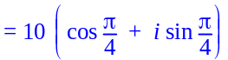

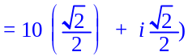 ✓

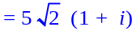 ✓

∴ Proved

[3]

Question 7: [5 marks]
Determine the gradient of the curve defined by the parametric equations: 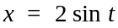 and 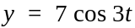, at the point where 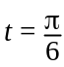.

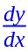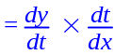

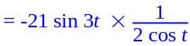 ✓✓

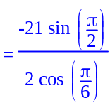 ✓

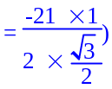 ✓

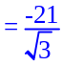

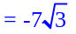 ✓

[5]

Question 8: [6 marks]
Determine the coordinates of the points on the graph of: 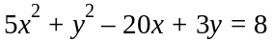, where the tangent to the curve is horizontal.

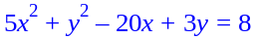

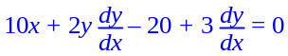 ✓

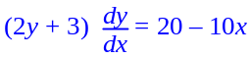

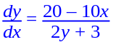 ✓

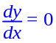 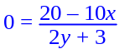 ✓

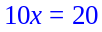

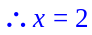 ✓

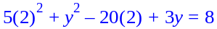

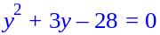

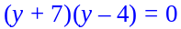

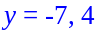 ✓

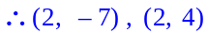 ✓

[6]

END OF SECTION ONE

